OFFICIAL COORDINATION REQUEST FOR
NON-ROUTINE OPERATIONS AND MAINTENANCE

COORDINATION TITLE – 22TDA MOC 14 Hydro-Survey of TDA Spillway and Navigation Lock
COORDINATION DATE - 12 October 2022
PROJECT - The Dalles Lock and Dam
RESPONSE DATE - 26 October 2022

Description of the problem – As part of the Periodic Inspection at The Dalles Lock and Dam, a hydro-survey of the spillway and downstream approach is needed. The last hydro-survey was conducted in 2018 and due to low tailwater there were data gaps. In reviewing previous hydro-surveys, a minimum Bonneville forebay of 74 feet should provide sufficient tailwater to get full coverage of The Dalles spillway. During the spillway hydro-survey The Dalles north ladder fish entrance will need to be shut down (Wasco PUD shutdown as well) while the survey is north of the 8/9 wall and The Dalles south spillway entrance to the east ladder will need to be shut down while the survey is south of the 8/9 spillwall.

Type of outage required-
- Minimum Bonneville Forebay of 74 feet
- Maximum 4-hour outage of the Wasco PUD and North Ladder Fish Entrance
- Maximum 4-hour outage of the South Spillway Entrance to the East Fish Ladder
- Fish units flow reduced by – 30% to provided criteria for the east and west entrances.

Impact on unit priority - None.

Impact on forebay/tailwater operation - None at TDA but requesting a minimum forebay at Bonneville (the request is in the normal range).

Impact on spill - Spill operations have finished for the season.

Dates of impacts/repairs – Week of October 31st, 2022

Length of time for repairs - 0700 to 1500.

Analysis of potential impacts to fish:
During the final week October, The Dalles has a 10-year average passage of approximately 1,000 total salmonids a day. Of these fish, approximately 95% use the east fish ladder and of those approximately 80% use the east fishway entrance. The east and west fishway entrance will maintain criteria during this operation. The operation will affect 15% of the total run. The closures will be in 4-hour blocks for each entrance resulting in 30% of the total daylight passage hours.

- 10-year average passage during the period of impacts.

Fig 1. The ten-year average passage for all species at The Dalles Dam during the week of 31 October to 4 December (Data from FPC).

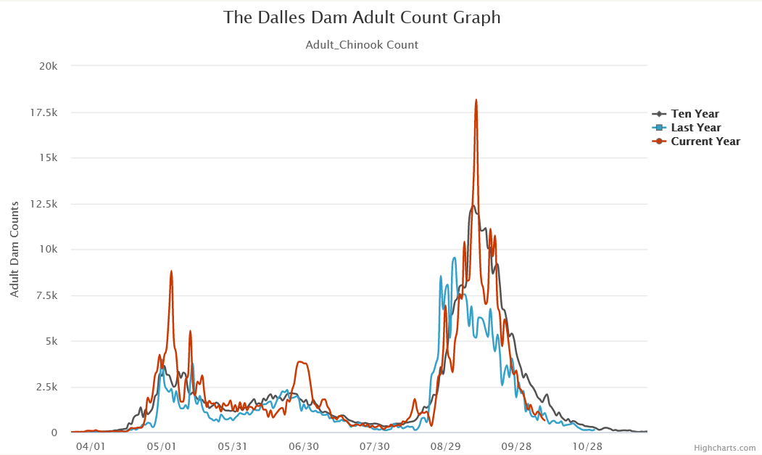
Fig 2. A graph of adult passage at The Dalles Dam. By the time of the operation, most salmonids have passed the dam (Data from FPC).

- Statement of the current years run:

The Dalles Dam Historical Fish Passage
Species | Ten-year average | Current year | Above/Below average
Spring Chinook | 113533 | 147118 | Well above average
Fall Chinook | 315442 | 2788921 | Below average
Coho | 51650 | 48242 | Slightly below average
Sockeye | 256662 | 580579 | Well above average
Steelhead | 113929 | 93864 | Below average
Lamprey | 11277 | 21776 | Well above average
Fig 3. The current years run at The Dalles Dam compared to the 10-year average (Data from FPC).

Impacts to upstream migrants (including Bull Trout) by date:
Some minimal delay may be seen at The Dalles during the maximum 4-hour closures as a result of the operation. However, the east and west fish ladders will maintain criteria throughout the operation and will provide passage. 95% of fish utilize the east fish ladder entrance, this rate may see a slight increase during the survey.

Impacts to upstream migrants (Lamprey)
The ten-year average for lamprey passage during this time shows no lamprey passing during this work period. Any affects from the operation are expected to be minimal.

Impacts to downstream migrants:
Impacts are expected to be minimal as the majority of salmonid and lamprey juvenile passage has concluded by the date of the operation.

Comments from agencies:

Final coordination results:

Please email or call with questions or concerns.
Thank you,

Steven Sachs
Fish and Wildlife Field Biologist
Fisheries Field Unit
USACE Portland District
(971) 284-6422

Laurie Ebner
Hydraulic Engineer
CENWP-ENC-HD
Work – 503-808-4880
Cell – 503-250-3404

